SET 7
1. Bar Chart – Customer Ages
Aim: To create a bar chart to visualize the distribution of customer ages and compare the ages of different customers.
Code:
# Customer data
customer <- data.frame(
Customer_ID = c(1, 2, 3),
Age = c(28, 35, 42),
Gender = c("Female", "Male", "Female"),
Income = c(50000, 60000, 75000)
)
# Bar chart
barplot(customer$Age,
names.arg = customer$Customer_ID,
main = "Distribution of Customer Ages",
xlab = "Customer ID",
ylab = "Age")

Output:
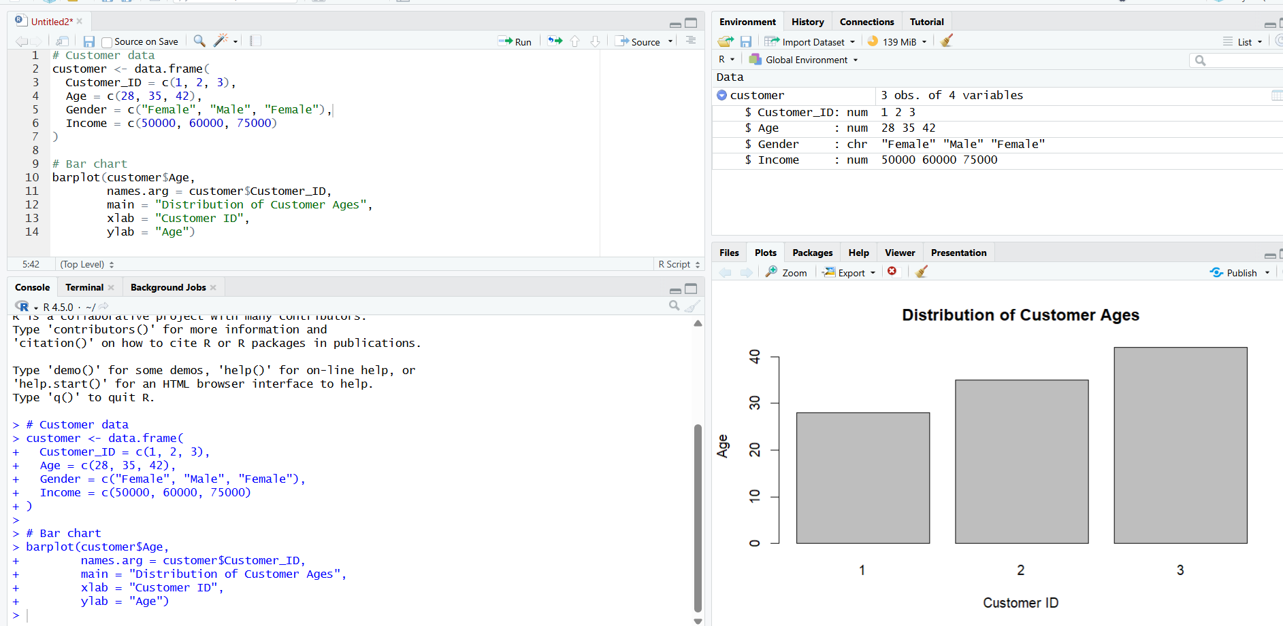

2. Pie chart – Distribution by Gender
Aim:
To generate a pie chart to represent the distribution of customers by gender.
CODE:
# Customer data
customer <- data.frame(
Customer_ID = c(1, 2, 3),
Age = c(28, 35, 42),
Gender = c("Female", "Male", "Female"),
Income = c(50000, 60000, 75000)
)
gender <- table(customer$Gender)
pie(gender,
main = "Distribution of Customers by Gender",
labels = paste(names(gender), gender),
col = c("pink", "lightblue"))
Output:
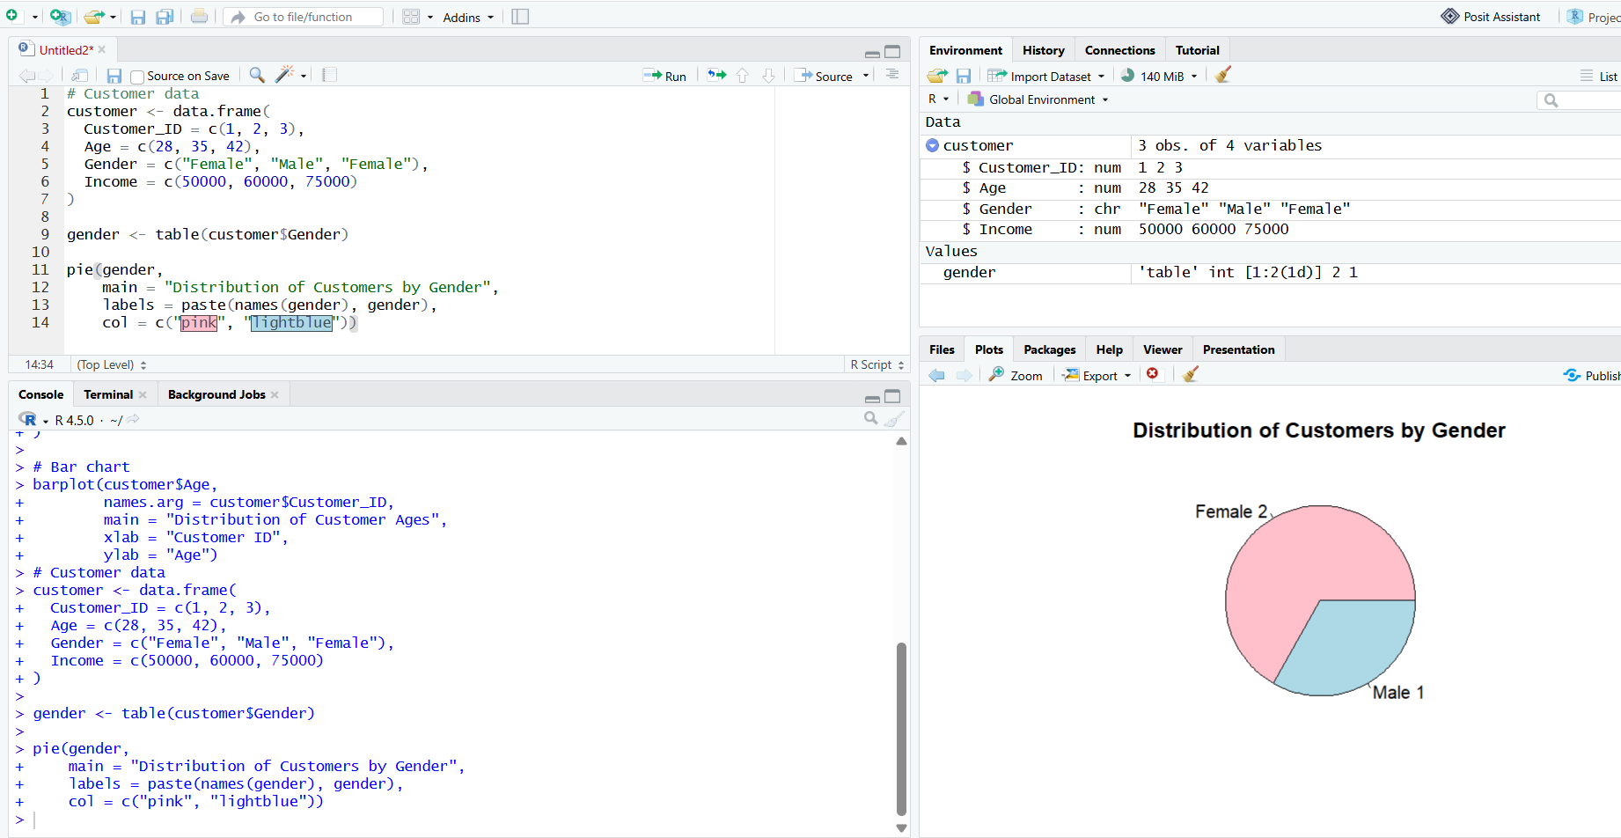
3. Demographic Table
Aim:
To create a table showing the demographic information of each customer and label the table elements.
Code:
customer <- data.frame(
Customer_ID = c(1, 2, 3),
Age = c(28, 35, 42),
Gender = c("Female", "Male", "Female"),
Income = c(50000, 60000, 75000)
)
colnames(customer) <- c("Customer ID", "Age", "Gender", "Income ($)")

print(customer, row.names = FALSE)
Output:
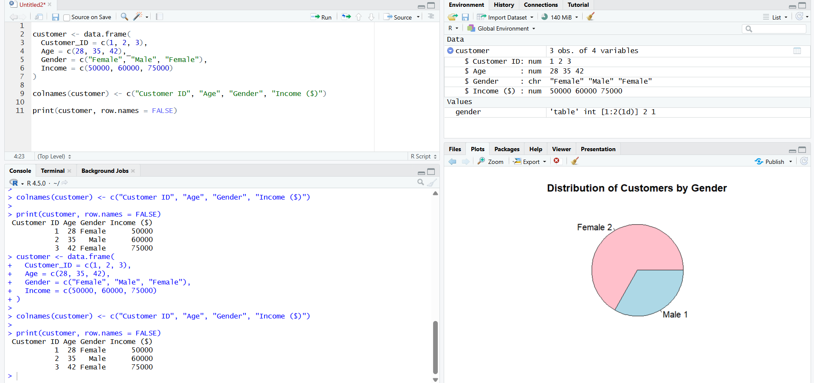
4.
AIM
To develop an interactive Tableau dashboard combining a bar chart, pie chart, and demographic table for customer demographic analysis.
Output:
